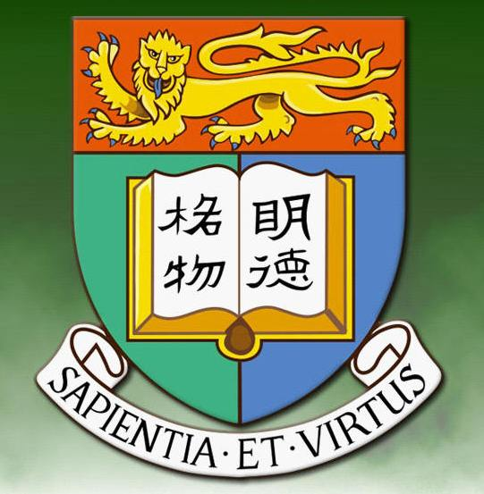
2007 Fall Gathering Report

By Sau-Fong Siu

The HKU Alumni Network of New England had its fall gathering at the Hei La Moon Restaurant in Boston Chinatown. It was attended by 31 alumni, 9 family members of alumni, and 3 exchanges students. Alumni in attendance spanned three generations with graduation dates ranging from the 1960s to the 2000s. For the first time we had an alum from Rhode Island joining us. The highlight of the evening was a lucky draw in which 14 prizes were given out. Joshua Lo, the young son of alumni Victor Lo and Florence Yong, assisted with the drawing. Before the gathering ended, Chi-Sang Poon, a singer/songwriter as well as a research scientist at MIT, gave each family a CD of his own vocal music “Radiations of Life.”

